Excellence In Construction
Associated Builders and Contractors of Rhode Island
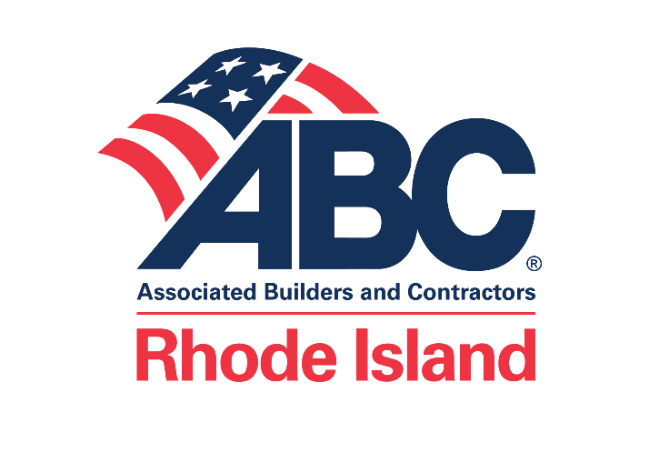
with presenting Sponsor

WINNERS WILL BE HONORED AT OUR AWARD CEREMONY WEDNESDAY OCTOBER 12, 2022

DEADLINE FOR ENTRIES: SEPTEMBER 16, 2022

IF YOU HAVE ANY QUESTIONS KINDLY CONTACT MAUREEN@ABCRI.ORG

2022 CRITERIA ENTRY SUGGESTIONS

ENTRIES CAN BE SUBMITTED IN A THREE RING BINDER WITH TABS INDICATING THE REQUIREMENTS BELOW ACCOMPANIED BY THE ENTRY FORM WITH YOUR COMPANY’S NAME AND ENTRY CATEGORY ON THE COVER.

- DETAILED DESCRIPTION OF PROJECT
- NARRATIVE: EMPHASIS ON CONSTRUCTION QUALITY (NOT DESIGN), SPECIAL CHALLENGES INCLUDING DIFFICULT SITE OR UNUSUAL CONSTRUCTION CONDITIONS, INNOVATIONS, RESPONSE TO UNEXPECTED CONDITIONS. PROJECT OPERATIONS, INCLUDING SAFETY, PERSONNEL MANAGEMENT AND QUALITY CONTROL. PROJECT ADMINISTRATION, INCLUDING SCHEDULING, GENERAL ADMINISTRATION, COOPERATION WITH OWNERS, DESIGNERS AND CONTRACTORS.
- SAFETY RECORD – OSHA 300 and 300A forms attached with personal information redacted required. Copy of company Safety & Health Policy manual attached. Company has signed ABC’s drug and alcohol free pledge https://www.drugfreeconstruction.org/
- PHOTOGRAPHS
- ENDORSEMENTS
- PRESS AND PROMOTION
- ABC MEMBER INVOVEMENT: LIST ALL MEMBERS
- PARTICIPATION IN STEP AND LEVEL ACHIEVED: http://www.abcstep.org/

PLEASE READ AND SIGN BELOW: I HAVE ENCLOSED MY CHECK FOR $75.00 TO COVER THE ENTRY FEE. ALSO, ENCLOSED IS MY ENTRY ADDRESSING THE REQUIREMENTS LISTED ABOVE. I HEREBY GIVE ABC MY PERMISSION TO USE PHOTOGRAPHS AND ANY INFORMATION SUBMITTED FOR THE EXCELLENCE IN CONSTRUCTION AWARDS PROGRAM IN ANY ABC AWARD MATERIAL, PROMOTIONAL MATERIAL AND PRESS RELEASES.

SIGNATURE AND TITLE OF PERSON COMPLETING FORM

_________________________________ ________________________________ ______________________
SIGNATURE TITLE DATE

ALL ENTRIES MUST BE SUBMITTED NO LATER THAN SEPTEMBER 16, 2022. WHEN COMPLETED, RETURN ENTRY FORM, ENTRY REQUIREMENTS AND CHECK TO:
ASSOCIATED BUILDERS AND CONTRACTORS
249 ROOSEVELT AVENUE SUITE 102 BOX 4
PAWTUCKET, RHODE ISLAND 02860

EXCELLENCE IN CONSTRUCTION 2022 ENTRY FORM

PLEASE FURNISH THE INFORMATION REQUESTED BELOW. NAME AND ADDRESSES SHOULD BE PRINTED OR TYPED AS THEY ARE TO APPEAR ON THE AWARD. A FEE OF $75.00 MUST ACCOMPANY EACH ENTRY. KINDLY MAKE CHECKS PAYABLE TO : ASSOCIATED BUILDERS AND CONTRACTORS, RI CHAPTER.

CONTRACTOR ENTERING PROJECT_________________________________________________________________

STREET /BOX ADDRESS__________________CITY: _________________________ STATE:______ ZIP:_________

INDIVIDUAL IN FIRM MOST FAMILIAR WITH PROJECT & AVAILABLE TO ANSWER QUESTIONS:

NAME ___________________TELEPHONE_________________ EMAIL _____________________
INDIVIDUAL(S) TO BE NOTIFIED IF AWARDED:
NAME ___________________TELEPHONE_________________ EMAIL _____________________
PROJECT BEING ENTERED:_________________________________________TOTAL COST OF PROJECT:____________

LOCATION/ADDRESS OF PROJECT:__________________________________

- NAME OF PRIMARY ARCHITECT/ENGINEER________________________________________
CONTACT NAME_________________________________________________________________
FIRM NAME______________________________________________________________________
ADDRESS________________________________________________________________________
TELEPHONE_____________________________________________ EMAIL ______________________

- NAME OF OWNER/DEVELOPER____________________________________________________
CONTACT NAME__________________________________________________________________
COMPANY NAME_________________________________________________________________
ADDRESS________________________________________________________________________
TELEPHONE_____________________________________________ EMAIL _______________________

START DATE OF CONTRUCTION__________________________ COMPLETION DATE______________________________

HAS THIS PROJECT WON ANY OTHER AWARDS?________IF SO, NAME OF AWARDS_____________________________

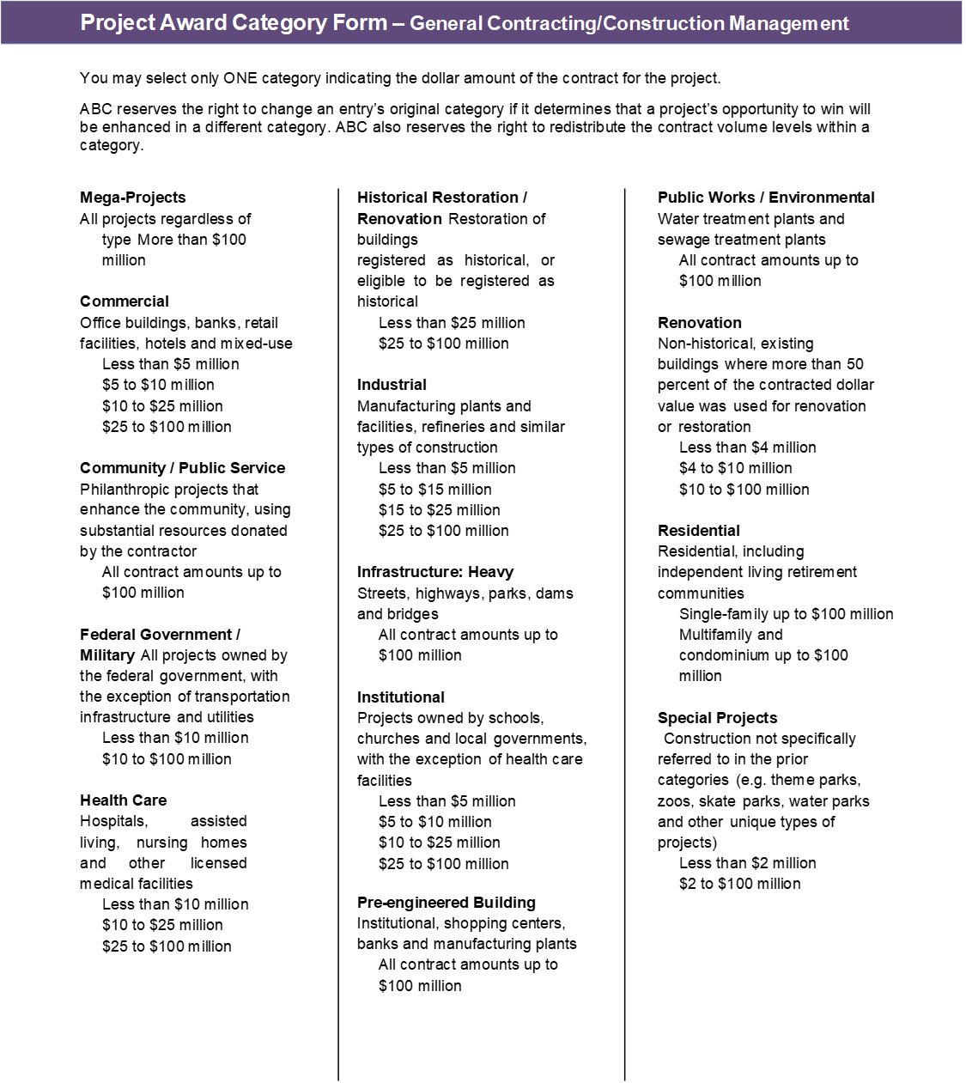
Safety Policy
A company that experiences a safety-related fatality of a direct employee in the United States within the current program year (Sept 14, 2020 -Sept 15, 2021) is NOT eligible for an Excellence in Construction Award. If a subsidiary is a direct ABC member versus part of a larger holding company member, then the subsidiary with a safety-related fatality is not eligible, but another subsidiary of the same holding company may be.
A company that experienced a safety-related fatality of a direct employee in the United States within two or three years of the current program year is required to provide additional information regarding action that has been taken following the fatality. (See Safety Requirements for additional details).
No project that involves prime, multi-prime or sub-trade contractors with a safety-related fatality is eligible to be considered for an award.

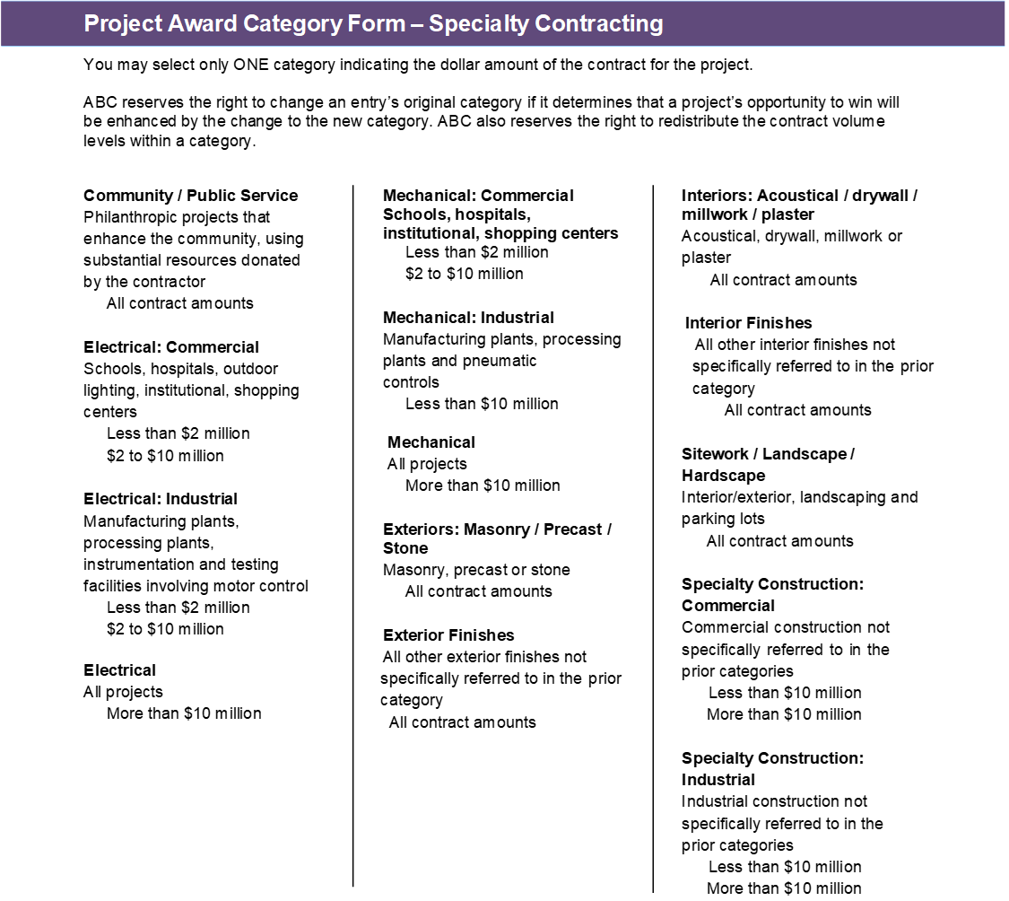

Safety Policy
A company that experiences a safety-related fatality of a direct employee in the United States within the current program year (Sept 14, 2020 – Sept 15, 2021) is NOT eligible for an Excellence in Construction Award. If a subsidiary is a direct ABC member versus part of a larger holding company member, then the subsidiary with a safety-related fatality is not eligible, but another subsidiary of the same holding company may be.
A company that experienced a safety-related fatality of a direct employee in the United States within two or three years of the current program year is required to provide additional information regarding action that has been taken following the fatality. (See Safety Requirements for additional details).
No project that involves prime, multi-prime or sub-trade contractors with a safety-related fatality is eligible to be considered for an award.

PROJECT AWARD CATEGORY - GENERAL CONTRACTING/ CONSTRUCTION MANAGEMENT
You may select ONE category indicating the dollar amount of the contract for the project.
( ) MEGA-PROJECTS – ALL PROJECTS REGARDLESS OF TYPE > $100 MILLION

( ) COMMERCIAL: OFFICE BUILDINGS, BANKS, HOTELS, RETAIL FACILITIES & MIXED USE ( ) LESS THAN $5 MILLON ( ) $5 TO $ 10 MILION ( ) $10 to $25 MILLION ( ) $25 TO $100 MILLION

( ) COMMUNITY/ PUBLIC SERVICE: PHILANTRHROPIC PROJECTS THAT ENHANCE THE COMMUNITY, USING SUBSTANTIAL RESOURCES DONATED BY THE CONTRACTOR ALL CONTRACT AMOUNTS UP TO $100 MILLION

( ) FEDERAL GOVERNMENT/MILITARY: ALL PROJECTS OWNED BY THE FEDERAL GOVERNMENT, WITH THE EXCEPTION OF TRANSPORTATION INFRASTRUCTURE AND ULTILIES ( ) LESS THAN $10 MILLION ( ) $10 MILLION TO $100 MILLION

( ) HEALTHCARE: HOSPITALS, ASSISTED LIVING, NURSING HOMES AND OTHER LICENSED MEDICAL FACILITIES ( ) LESS THAN $10 MILLION ( ) $10 TO $25 MILLION ( ) $25 TO $100 MILLION

( ) INSTITUTIONAL: PROJECTS OWNED BY SCHOOLS, CHURCHES AND LOCAL GOVERNMENTS, WITH THE EXCEPTION OF HEALTH CARE FACILITIES ( ) LESS THAN $5 MILLION ( ) $5 TO $10 MILLION ( ) $10 TO $25 MILLION ( ) $25 TO $100 MILLION

( ) INDUSTRIAL: MANUFACTURING PLANTS AND FACILITIES, REFINERIES AND SIMILAR TYPES OF CONSTRUCTION ( ) LESS THAN $5 MILLION ( ) $5 TO $15 MILLION ( ) $15 TO $25 MILLION ( ) $25 TO $100 MILLION

( ) INFRASTRUCTURE: HEAVY STREETS, HIGHWAYS, PARKS, DAMS AND BRIDGES ALL CONTRACT AMOUNTS UP TO $100 MILLION

( ) HISTORICAL RESTORATION/ RENOVATION RESTORATION OF BUILDINGS REGISTERED AS HISTORICAL , OR ELIGIBLE TO BE REGISTERED AS HISTORICAL ( ) LESS THAN $25 MILLION ( ) $25 TO $100 MILLION

( ) RENOVATION: NON – HISTORICAL, EXISTING BUILDINGS WHERE MORE THAN 50 PERCENT OF THE CONTRACTED DOLLAR VALUE WAS USED FOR RENOVATION OR RESORATION ( ) LESS THAN $4 MILLION ( ) $4 TO $10 MILLION ( ) $10 TO $100 MILLION

( ) PRE-ENGINEERED BUILDING: INSTITUIONAL, SHOPPING CENTERS, BANKS, AND MANUFACTURING PLANTS ALL CONTRACTS AMOUNTS UP TO $100 MILLION

( ) PUBLIC WORKS / ENVIRONMENTAL: WATER TREATMENT PLANTS AND SEWAGE TREATMENT PLANTS ALL CONTRACTS UP TO $100 MILLION

( ) RESIDENTIAL: RESIDENTIAL INCLUDING INDEPENDENT LIVING RETIREMENT COMMUNITIES ( ) SINGLE- FAMILY UP TO $100 MILLION ( ) MULTIFAMILY AND CONDOMINUIUM UP TO $100 MILLION

( ) SPECIAL PROJECTS: CONSTRUCTION NOT SPECIFICALLY REFERRED TO IN THE PRIOR CATEGORIES EXAMPLES SUCH AS THEME PARKS, ZOOS, SKATE PARKS, WATER PARKS AND OTHER UNIQUE TYPE PROJECTS ( ) LESS THAN $2 MILLION ( ) $2 TO $100 MILLION

PROJECT AWARD CATEGORY- SPECIALITY CONTRACTING
You may select ONE category indicating the dollar amount of the contract for the project.

( ) COMMUNITY/ PUBLIC SERVICE: PHILANTHROPIC PROJECTS THAT ENHANCE THE COMMUNITY, USING SUBSTANTIAL RESOURCES DONATED BY THE CONTRACTOR ALL CONTRACT AMOUNTS
( ) ELECTRICAL - COMMERCIAL: SCHOOLS, HOSPTIALS, OUTDOOR LIGHTING, INSTITUTIONAL, SHOPPING CENTERS ( ) LESS THAN $2MILLION ( ) $2 TO $10 MILLION
( ) ELECTRICAL – INDUSTRIAL: MANUFACTURING PLANTS, PROCESSING PLANTS, INSTRUMENTATION AND TESTING FACILITIES INVOLVING MOTOR CONTROL ( ) LESS THAN $2 MILLION ( ) $2 TO $10 MILLION
( ) ELECTRICAL: ALL PROJECTS MORE THAN $10 MILLION
( ) MECHANICAL - COMMERCIAL: SCHOOLS, HOSPITALS, INSTITUTIONAL, SHOPPING CENTERS ( ) LESS THAN $2 MILLION ( ) $2 TO $10 MILLION
( ) MECHANICAL – INDUSTRIAL: MANUFACTURING PLANTS, PROCESSING PLANTS AND PNEUMATIC CONTROLS LESS THAN $10 MILLION
( ) MECHANICAL: ALL PROJECTS MORE THAN $10 MILLION
( ) EXTERIORS: MASONRY/PRECAST/STONE MASONRY, PRECAST OR STONE ALL CONTRACT AMOUNTS
( ) EXTERIOR FINISHES: ALL OTHER EXTERIOR FINISHES NOT SPECIFICALLY REFERRED TO IN THE CATEGORY ALL CONTRACT AMOUNTS
( ) INTERIORS: ACOUSTICAL /DRYWALL/MILLWORK/ PLASTER ALL CONTRACT AMOUNTS

( ) INTERIOR FINISHES: ALL OTHER INTERIOR FINISHES NOT SPECIFICALLY REFERRED TO IN THE PRIOR CATEGORY ALL CONTRACT AMOUNTS

( ) SITEWORK / LANDSCAPE / HARDSCAPE: INTERIOR /EXTERIOR, LANDSCAPING AND PARKING LOTS ALL CONTRACT AMOUNTS

( ) SPECIALITY CONSTRUCTION – COMMERCIAL: COMMERCIAL CONSTRUCTION NOT SPECIFICALLY REFERRED TO IN THE PRIOR CATEGORIES ( ) LESS THAN $10 MILLION ( ) MORE THAN $10 MILLION

( ) SPECIALITY CONSTRUCTION – INDUSTRIAL: INDUSTRIAL CONSTRUCTION NOT SPECIFICALLY REFERRED TO IN THE PRIOR CATEGORIES ( ) LESS THAN $10 MILLION ( ) MORE THAN $10 MILLION

